Thévenin’s Theorem

4.34 Main Question (สำหรับแสดงข้อสอบ)

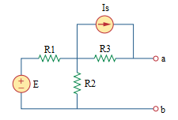

Given *E* = 40 V, *Is* = 3 A, *R*1 = 10 Ω, *R*2 = 40 Ω, *R*3 = 20 Ω.

Find the Thévenin equivalent circuit at terminals a-b.

*RTH* =

*VTH* =

Variables (สำหรับเขียนโค้ดเพื่อหาคำตอบ)

Random variables

E = {10:100:10}; IS = {1:10};

R1 = {1:100}; R2 = {1:100}; R3 = {1:100};

Global variables

#E = 40; IS = 3; R1 = 10; R2 = 40; R3 = 20;

RTH = R1\*R2/(R1+R2)+R3;

VTH = (R1\*R2\*R3\*IS-R2\*R3\*E+(R1\*R2+R2\*R3+R1\*R3)\*(-IS\*R3))/((1-(R1\*R2+R2\*R3+R1\*R3)/(R1\*R2))\*(R1\*R2));

Part (กรอกคำตอบ)

1. RTH = 28 Ω

2. VTH = 92 V (assume the positive terminal of the voltage source is placed at the top)

4.36 Main Question (สำหรับแสดงข้อสอบ)

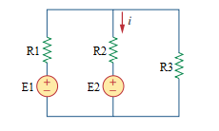

Given *E1* = 50 V , *E2* = 30 V , *R*1 = 10 Ω, *R*2 = 12 Ω, *R*3 = 40 Ω.

Find the Thévenin equivalent circuit at R2.

*RTH* =

*VTH* =

I =

Variables (สำหรับเขียนโค้ดเพื่อหาคำตอบ)

Random variables

E1 = {10:100:10}; E2 = {10:100:10};

R1 = {1:100}; R2 = {1:100}; R3 = {1:100};

Global variables

#E1 = 50; E2 = 30; R1 = 10; R2 = 12; R3 = 40;

RTH = R1\*R3/(R1+R3);

VTH = R3/(R1+R3)\*E1;

I = (VTH-E2)/(RTH+R2);

Part (กรอกคำตอบ)

1. RTH = 8 Ω

2. VTH = 40 V (assume the positive terminal of the voltage source is placed at the top)

3. I = 0.5 A

4.37 Main Question (สำหรับแสดงข้อสอบ)

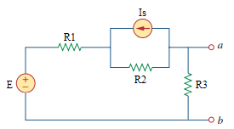

Given *E* = 120 V , *Is* = 2 A, *R*1 = 20 Ω, *R*2 = 40 Ω, *R*3 = 12 Ω.

Find the Norton equivalent circuit at terminals a-b.

*RN* =

*ISC* =

Variables (สำหรับเขียนโค้ดเพื่อหาคำตอบ)

Random variables

E = {10:200:10}; IS = {1:10};

R1 = {1:100}; R2 = {1:100}; R3 = {1:100};

Global variables

#E = 120; IS = 2; R1 = 20; R2 = 40; R3 = 12;

RN = R3\*(R1+R2)/(R1+R2+R3);

ISC = (E-IS\*R2)/(R1+R2);

Part (กรอกคำตอบ)

1. RN = 10 Ω

2. ISC = 0.666 A

4.38 Main Question (สำหรับแสดงข้อสอบ)

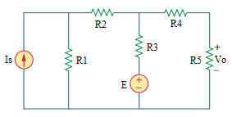

Given *E* = 12 V, *Is* = 3 A, *R*1 = 16 Ω, *R*2 = 4 Ω, *R*3 = 5 Ω, *R*4 = 1 Ω, *R*5 = 10 Ω.

Find the Thévenin equivalent circuit for the network external to the resistor R5.

*RTH* =

*VTH* =

Determine the maximum power to R5.

Variables (สำหรับเขียนโค้ดเพื่อหาคำตอบ)

Random variables

E = {1:20}; IS = {1:20};

R1 = {1:20}; R2 = {1:20}; R3 = {1:20}; R4 = {1:20}; R5 = {1:20};

Global variables

#E = 12; IS = 3; R1 = 16; R2 = 4; R3 = 5; R4 = 1; R5 = 10;

RTH = R4+R3\*(R1+R2)/(R1+R2+R3);

VTH = ((R1\*R2\*R3\*IS)/(R1+R2)+R2\*E)/(R2+R3-(R1\*R3)/(R1+R2));

VO = R5/(R5+RTH)\*VTH;

P = (VO\*VO)/(R5);

Part (กรอกคำตอบ)

1. RTH = 5 Ω

2. VTH = 19.2 V (assume the positive terminal of the voltage source is placed at the top)

3. P = 16.384 W

4.39 Main Question (สำหรับแสดงข้อสอบ)

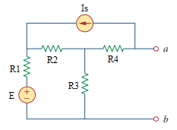

Given *E* = 24 V, *Is* = 3 A, *R*1 = 10 Ω, *R*2 = 10 Ω, *R*3 = 5 Ω, *R*4 = 16 Ω.

Find the Thévenin equivalent circuit at terminals a-b.

*RTH* =

*VTH* =

Variables (สำหรับเขียนโค้ดเพื่อหาคำตอบ)

Random variables

E = {1:50}; IS = {1:10};

R1 = {1:20}; R2 = {1:20}; R3 = {1:20}; R4 = {1:20};

Global variables

#E = 24; IS = 3; R1 = 10; R2 = 10; R3 = 5; R4 = 16;

RTH = R4+((R1+R2)\*R3/(R1+R2+R3));

VTH = (R3\*(R2\*E+R1\*R2\*IS)/(R1+R2)-R2\*R3\*IS)/(R2+R3-(R1\*R3/(R1+R2)))-R4\*IS;

Part (กรอกคำตอบ)

1. RTH = 5 Ω

2. VTH = 19.2 V (assume the positive terminal of the voltage source is placed at the top)

4.48 Main Question (สำหรับแสดงข้อสอบ)

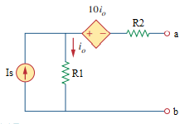

Given *Is* = 2 A , *R*1 = 4 Ω, *R*2 = 2 Ω.

Find the Norton equivalent circuit at terminals a-b.

*RN* =

*ISC* =

Determine the maximum power to R1.

Variables (สำหรับเขียนโค้ดเพื่อหาคำตอบ)

Random variables

IS = {1:10};

R1 = {1:10}; R2 = {1:10};

Global variables

#IS = 2; R1 = 4; R2 = 2;

RN = R1+R2-10;

ISC = (-10\*IS+R1\*IS)/RN;

P = IS\*IS\*R1;

Part (กรอกคำตอบ)

1. RN = -4 Ω

2. ISC = 3 A

3. P = 16 W

4.52 Main Question (สำหรับแสดงข้อสอบ)

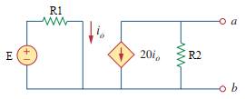

Given *E* = 6 V , *R*1 = 3000 Ω, *R*2 = 2000 Ω.

Find the Thévenin equivalent circuit at terminals a-b.

*RTH* =

*VTH* =

Variables (สำหรับเขียนโค้ดเพื่อหาคำตอบ)

Random variables

E = {1:10};

R1 = {1000:10000:1000}; R2 = {1000:10000:1000};

Global variables

#E = 6; R1 = 3000; R2 = 2000;

VTH = -R2\*20\*(E/R1);

RTH = VTH/(-20\*E/R1);

Part (กรอกคำตอบ)

1. RTH = 2000 Ω

2. VTH = -80 V (assume the positive terminal of the voltage source is placed at the top)

4.53 Main Question (สำหรับแสดงข้อสอบ)

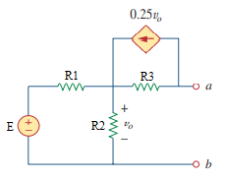

Given *E* = 18 V , *R*1 = 6 Ω, *R*2 = 3 Ω, *R*3 = 2 Ω.

Find the Norton equivalent circuit at terminals a-b.

*RN* =

*ISC* =

Variables (สำหรับเขียนโค้ดเพื่อหาคำตอบ)

Random variables

E = {1:20};

R3 = {1:10};

Global variables

#E = 18; R1 = 6; R2 = 3; R3 = 2;

RN = R3\*(1-0.25\*(R1\*R2/(R1+R2)))+(R1\*R2/(R1+R2));

ISC = (1/R3-0.25)\*( R2\*R3\*E/(R1\*R2+R1\*R3-0.25\*R1\*R2\*R3+R2\*R3));

Part (กรอกคำตอบ)

1. RN = 3 Ω

2. ISC = 1 A

4.63 Main Question (สำหรับแสดงข้อสอบ)

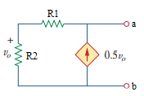

Given *R*1 = 10 Ω, *R*2 = 20 Ω.

Find the Norton equivalent circuit at terminals a-b.

*RN* =

*ISC* =

Variables (สำหรับเขียนโค้ดเพื่อหาคำตอบ)

Random variables

R1 = {1:20}; R2 = {1:20};

Global variables

#R1 = 10; R2 = 20;

RN = 1/(1/(R1+R2)-0.5\*(R2/(R1+R2)));

ISC = 0;

Part (กรอกคำตอบ)

1. RN = -3.333 Ω

2. ISC = 0 A

4.64 Main Question (สำหรับแสดงข้อสอบ)

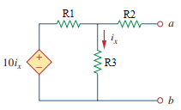

Given *R*1 = 4 Ω, *R*2 = 1 Ω, *R*3 = 2 Ω.

Find the Thévenin equivalent circuit at terminals a-b.

*RTH* =

*VTH* =

Variables (สำหรับเขียนโค้ดเพื่อหาคำตอบ)

Random variables

R1 = {1:10}; R2 = {1:10}; R3 = {1:10};

Global variables

#R1 = 4; R2 = 1; R3 = 2;

RTH =1/((1-( R1/(R2\*R1/R3+R1-10\*R2/R3+R2)))/R2);

VTH = 0;

Part (กรอกคำตอบ)

1. RTH = -1 Ω

2. VTH = 0 V (assume the positive terminal of the voltage source is placed at the top)